|  |  |  |  |  |
| --- | --- | --- | --- | --- |
| Tanggal Lapor | Nama Sistem | Versi | Deskripsi | Dokumen |
|  |  |  |  |  |

|  |  |  |  |  |
| --- | --- | --- | --- | --- |
| Tanggal Lapor | Nama Sistem | Kendala | Keterangan | Foto |
|  |  |  |  |  |

|  |  |  |  |  |
| --- | --- | --- | --- | --- |
| Tanggal Lapor | Nama Sistem | Versi | Deskripsi | Dokumen |
|  |  |  |  |  |

|  |  |  |  |  |
| --- | --- | --- | --- | --- |
| Tanggal Lapor | Nama Sistem | Kendala | Keterangan | Dokumen |
|  |  |  |  |  |

|  |  |  |  |  |  |  |  |  |
| --- | --- | --- | --- | --- | --- | --- | --- | --- |
| Tanggal Audit | Nama Sistem | Versi | Bahasa Pemrograman | Framework | Maksimum Penyimpanan | Maksimum Pengguna | Keamanan Sistem | Pengguna Sistem |
|  |  |  |  |  |  |  |  |  |

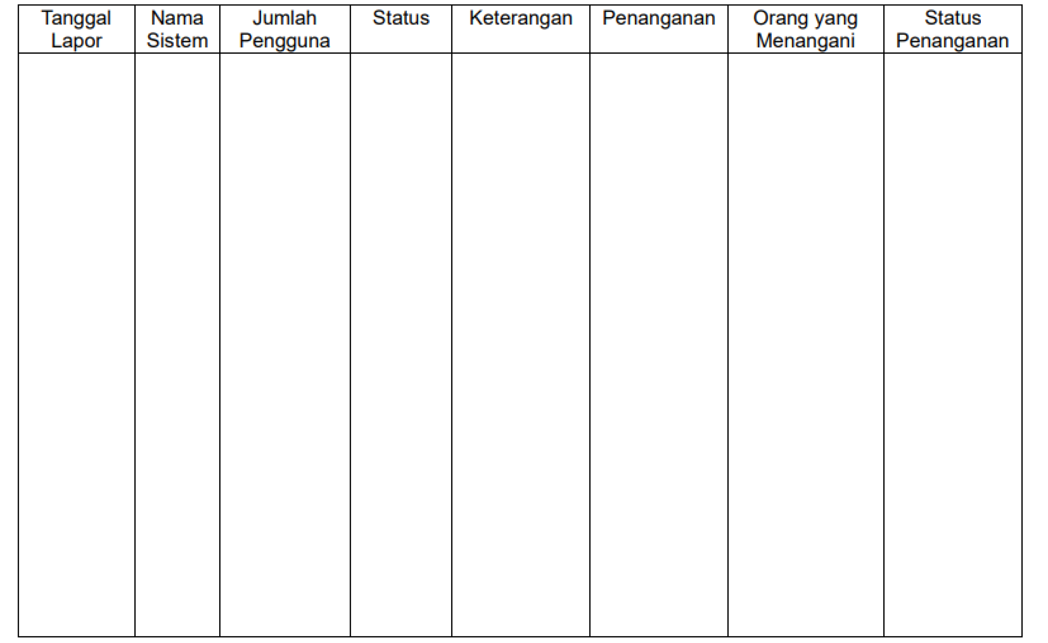

|  |  |  |  |  |  |  |  |
| --- | --- | --- | --- | --- | --- | --- | --- |
| Tanggal Audit | Nama Sistem | Versi |  |  |  |  |  |
|  |  |  |  |  |  |  |

|  |  |  |  |  |  |  |
| --- | --- | --- | --- | --- | --- | --- |
| Tanggal Lapor | Nama Sistem | Versi | Kendala | Keterangan | Penanganan | Status Penanganan |
|  |  |  |  |  |  |  |